Brain Tumor Detection System
API Design & UI/UX Design

API Schemas, Error Format, Wireframes, and User Flows

Graduation Project — 2026

Table of Contents

Part 1: API Design
This section expands on the API endpoint documentation by providing full request/response JSON schemas, the standardized error response format, and authentication flow details.

1. Standardized Error Response Format
All API endpoints return errors in a consistent JSON format. This enables the React frontend to handle errors uniformly.
{
"success": false,
"error": {
"code": "VALIDATION_ERROR",
"message": "Headache severity must be 0-10",
"details": [
{ "field": "headache_severity", "issue": "out_of_range" }
]
}
}

1.1 Error Codes
Error Code | HTTP | Description
VALIDATION_ERROR | 400 | Request body failed validation. Details array lists invalid fields.
UNAUTHORIZED | 401 | Missing or invalid JWT token. Client should redirect to login.
FORBIDDEN | 403 | Valid token but insufficient role. e.g., patient accessing admin endpoint.
NOT_FOUND | 404 | Resource not found. e.g., scan ID does not exist.
DUPLICATE_EMAIL | 409 | Email already registered. User should login instead.
FILE_INVALID | 422 | Uploaded file format or size is not acceptable.
AI_SERVICE_ERROR | 502 | FastAPI AI service unavailable or returned error.
INTERNAL_ERROR | 500 | Unexpected server error. Logged for debugging.

2. Authentication Endpoint Schemas

2.1 POST /api/auth/register
Request body:
{ "name": "Basel Mohamed", "email": "basel@example.com",
"password": "MySecure123", "role": "patient" }
Success response (201):
{ "success": true, "data": { "id": "uuid",
"email": "basel@example.com", "role": "patient" },
"message": "Account created successfully" }

2.2 POST /api/auth/login
Request body:
{ "email": "basel@example.com", "password": "MySecure123" }
Success response (200):
{ "success": true, "data": {
"accessToken": "eyJhbGci...", "refreshToken": "eyJhbGci...",
"user": { "id": "uuid", "name": "Basel", "role": "patient" }
} }

2.3 POST /api/auth/register/doctor
Request: Multipart form data
- name: string (required)
- email: string (required, valid email)
- password: string (required, min 8 chars)
- specialization: string (required)
- years_experience: integer (optional)
- license: file (required, PDF/JPEG/PNG, max 10MB)
Success response (201):
{ "success": true, "data": { "id": "uuid",
"verification_status": "pending" },
"message": "Registration pending admin verification" }

3. Scan Endpoint Schemas

3.1 POST /api/scans — Upload MRI and trigger AI
Request: Multipart form data with JWT header
- mri_image: file (required, JPEG/PNG, max 50MB)
- intake_form: JSON string containing 14 patient features
intake_form JSON structure:
{ "age": 45, "gender": "male",
"family_cancer_history": true,
"previous_treatment": false,
"comorbidities": "diabetes",
"headache_severity": 7,
"seizure_history": true,
"vision_problems": false,
"cognitive_changes": true,
"nausea_vomiting": false,
"functional_status": "needs_some_help",
"neurological_symptoms": "moderate",
"immunosuppressed": false }
Success response (200):
{ "success": true, "data": {
"scan_id": "uuid",
"tumor_type": "glioma",
"tumor_location": "Frontal lobe",
"tumor_size_mm2": 1247.50,
"hemisphere": "left",
"classification_confidence": 0.943,
"treatment_plan": "Surgical resection + radiation",
"urgency_level": "High",
"triage_tier": "emergency",
"segmentation_mask_url": "/uploads/masks/uuid.png"
} }

3.2 GET /api/scans — Patient scan history
Response (200):
{ "success": true, "data": [
{ "id": "uuid", "created_at": "2026-04-28T...",
"tumor_type": "glioma", "tumor_size_mm2": 1247.5,
"triage_tier": "emergency", "status": "completed" },
{ "id": "uuid2", "created_at": "2026-03-15T...",
"tumor_type": "meningioma", "tumor_size_mm2": 834,
"triage_tier": "urgent", "status": "completed" }
] }

4. Consultation Endpoint Schemas

4.1 POST /api/consultations — Book consultation
Request:
{ "scan_id": "uuid", "doctor_id": "uuid" }
Response (201):
{ "success": true, "data": { "id": "uuid",
"status": "pending", "doctor_name": "Dr. Ahmed" } }

4.2 POST /api/consultations/:id/notes — Doctor clinical notes
Request (Doctor JWT required):
{ "ai_agreement": "partially_agree",
"clinical_notes": "The AI correctly identified...",
"alternative_recommendation": "Consider watchful..." }
Response (200):
{ "success": true, "message": "Notes saved", "data": {
"status": "completed" } }

4.3 Internal: POST /predict — FastAPI AI endpoint
Request: Multipart from Node.js scan orchestrator
- image: MRI file binary
- features: JSON string with 14 patient features
Response (200):
{ "tumor_type": "glioma",
"tumor_location": "Frontal lobe",
"tumor_size_mm2": 1247.50,
"hemisphere": "left",
"classification_confidence": 0.943,
"treatment_plan": "Surgical resection + radiation",
"urgency_level": "High",
"triage_tier": "emergency" }

Part 2: UI/UX Design
This section presents wireframe mockups for 6 key pages and a user flow diagram showing screen-to-screen navigation across all three user roles.

5. Design System
Primary palette: Deep teal #0B4F6C (headers, nav, buttons) + Sky blue #01BAEF (links, accents)
Backgrounds: White #FFFFFF (content) + Ice gray #F7F9FC (sections) + Near-black #1A1A2E (text)
Triage colors (strict): Emergency #D32F2F (red) | Urgent #E65100 (amber) | Routine #1B7D3A (green) — NEVER used decoratively
Typography: Inter font. Hero 48px, section headings 24px, body 16px, captions 13px
Breakpoints: Mobile 360px+, Tablet 768px+, Desktop 1024px+
Components: Rounded buttons (pill shape), card-based layouts, shadow-sm elevation, 8px border radius

6. Page Wireframes

6.1 Landing Page
The first page visitors see. Contains the hero section with a CTA, the 3-step process explainer (Fill form → Upload MRI → Get results), trust indicators (AI-powered, 3-tier triage, doctor verified), and a medical disclaimer banner.
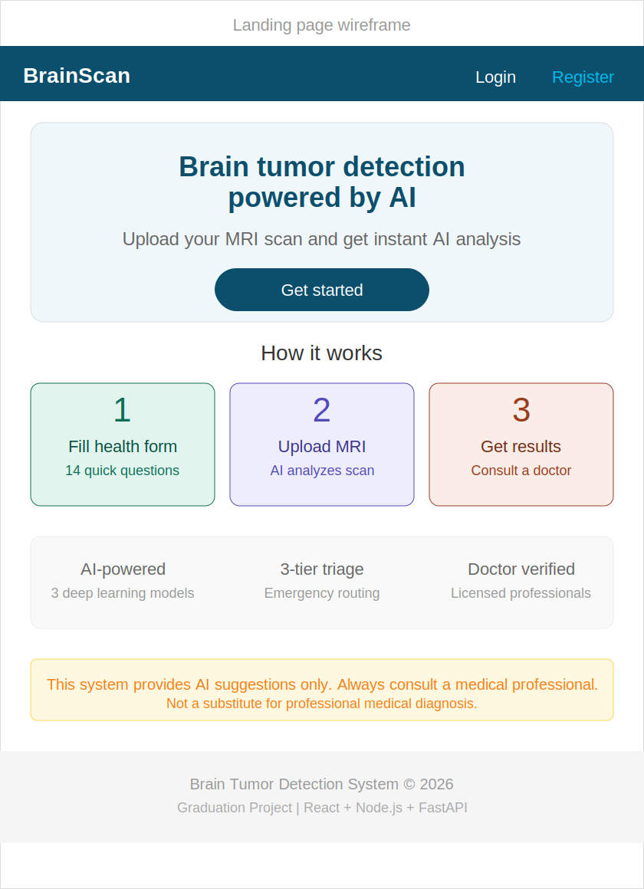
Figure 6.1 — Landing page wireframe

6.2 Results Page (Emergency variant)
The most important page in the system. Shows the emergency triage banner (red), 3-panel MRI view (original, segmentation overlay, annotated), findings cards (tumor type with confidence, location, size in mm², hemisphere), brain region diagram, treatment suggestion, and triage-driven CTAs. The emergency variant shows a red “Find nearest hospital” button prominently. Urgent and routine variants replace this with different CTAs.
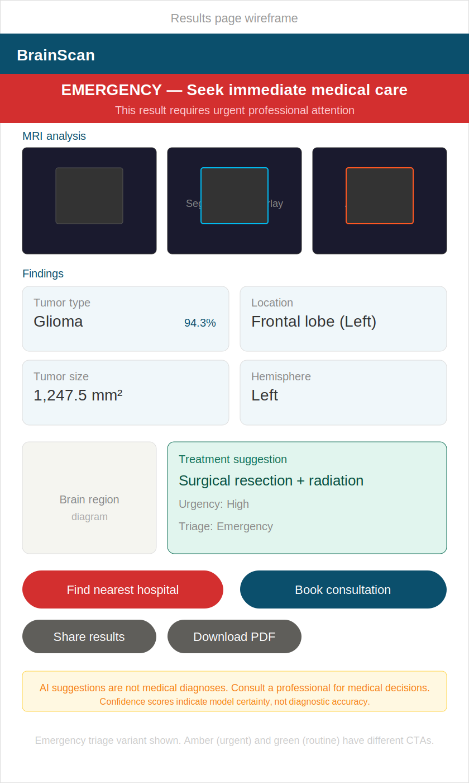
Figure 6.2 — Results page wireframe (emergency triage variant)

6.3 Patient Dashboard
The patient home screen after login. Shows quick action cards (New scan, Find doctor, Messages with unread count), a scan history table with date/tumor type/size/triage badge/view link, and active consultations with doctor name, scan reference, and status (Notes available or Pending).
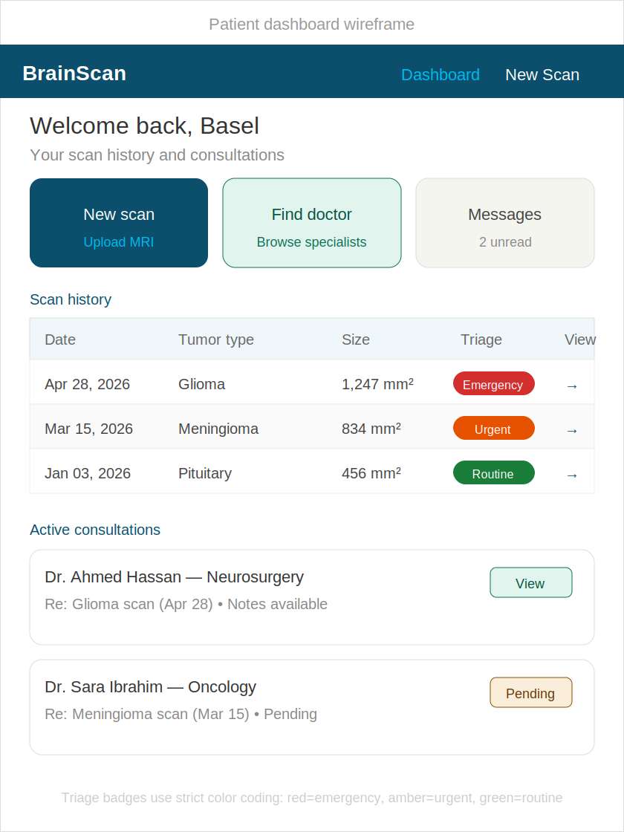
Figure 6.3 — Patient dashboard wireframe

6.4 Intake Form Wizard (Step 3)
The 4-step form wizard showing Step 3 (Symptoms). Includes a progress bar, step labels with checkmarks for completed steps, and form controls: slider for headache severity (0-10), toggle buttons for yes/no questions (seizure history, vision problems, cognitive changes, nausea/vomiting). Back/Next navigation buttons and auto-save indicator at bottom.
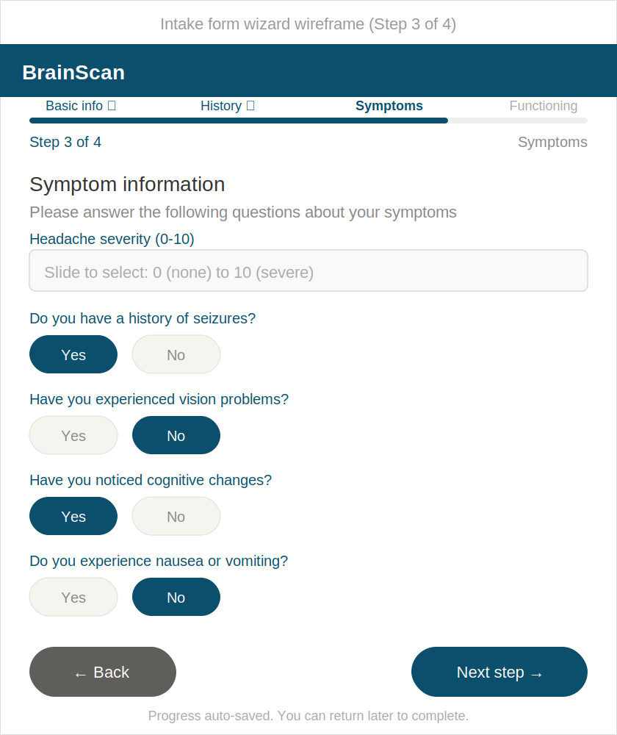
Figure 6.4 — Intake form wizard wireframe (Step 3 of 4)

6.5 Doctor Dashboard
The doctor home screen. Shows stat cards (pending requests, active patients, completed, average rating), incoming consultation requests with patient name, tumor summary, triage badge, and Accept/Decline buttons, and active patients currently under review with Write Notes and Review AI action buttons.
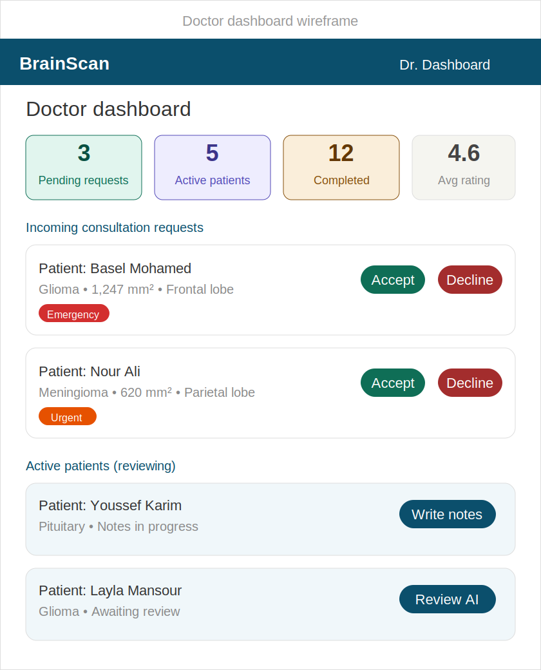
Figure 6.5 — Doctor dashboard wireframe

6.6 Admin Panel
The admin overview page. Shows system statistics (total scans, active doctors, consultations, AI-doctor agreement rate), the doctor verification queue with Approve/Reject buttons and View License link, quick navigation to Manage Users and View Statistics, and a tumor type distribution bar.
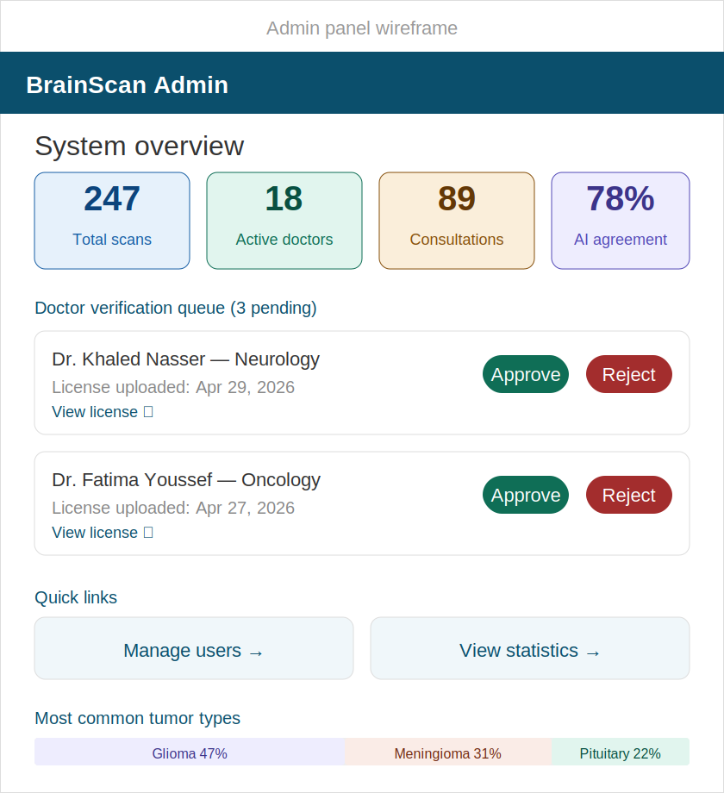
Figure 6.6 — Admin panel wireframe

7. User Flow Diagram
This diagram shows the screen-to-screen navigation paths across all three user roles. Each screen is a rounded rectangle color-coded by role: blue for public/auth, green for patient, purple for AI processing, coral for doctor, and pink for admin. The triage-driven routing from the Results page shows red/amber/green arrows branching to different CTAs.

Patient flow (green): Dashboard → Intake Form (4 steps) → MRI Upload → AI Results → triage branching to Nearest Hospital / Book Consultation / Follow Up Later
Doctor flow (coral): Dashboard → Doctor Listing → Doctor Profile → Consultation (chat + notes)
Admin flow (pink): Admin Panel → Verify Doctors / Manage Users / System Stats

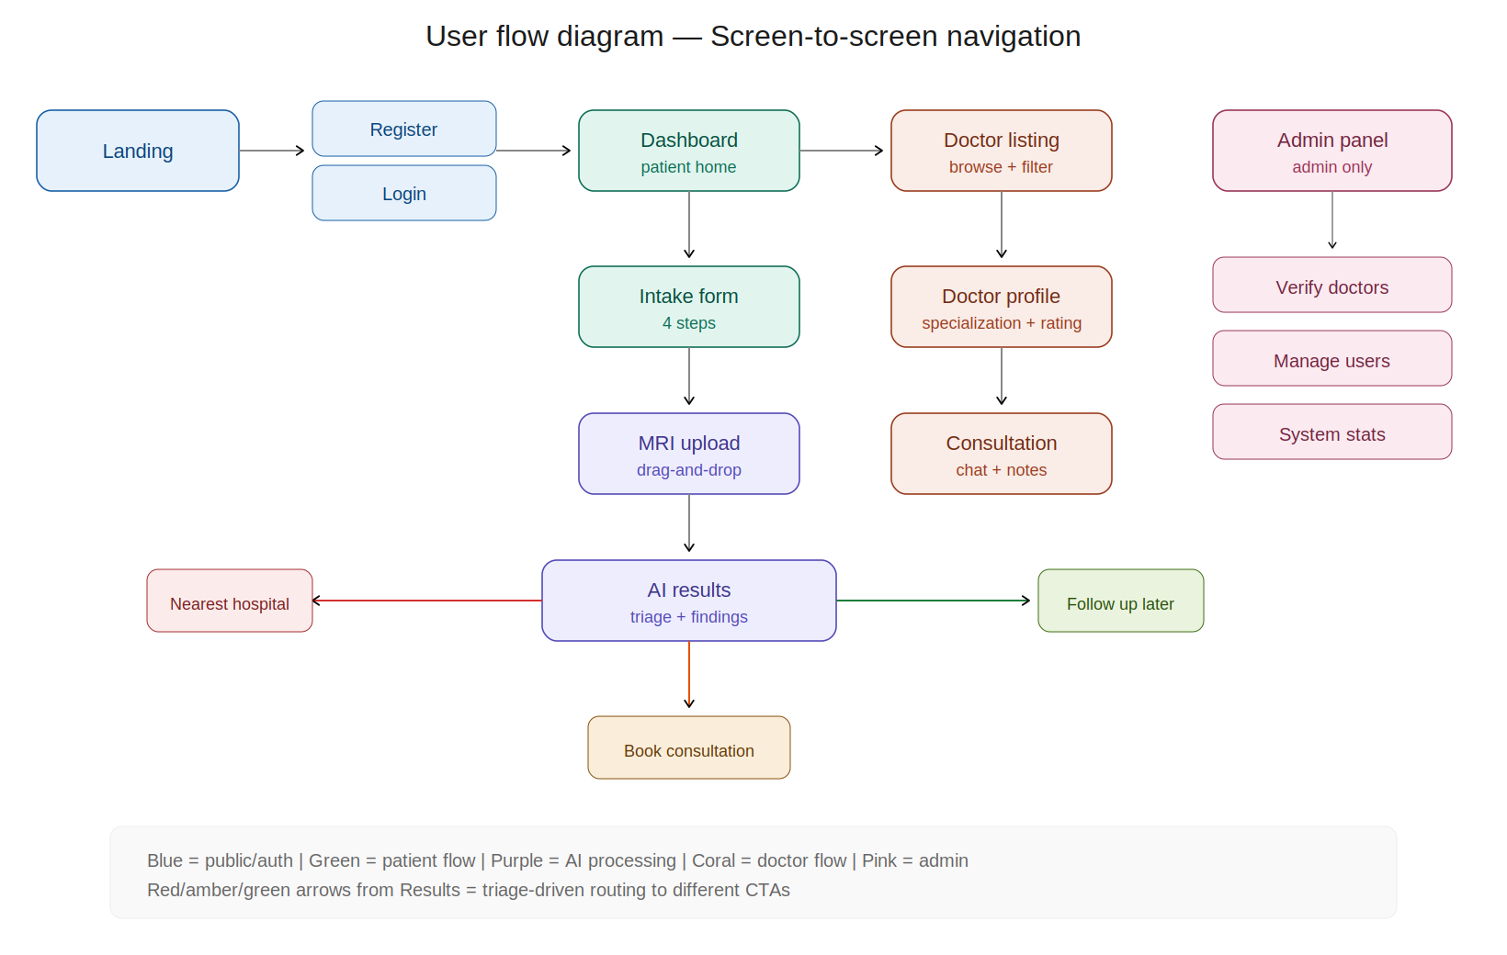
Figure 7.1 — User flow diagram — screen-to-screen navigation

